

Section: BD 14872 Course Number: 202301_CCCS215 Group: (2)

Table Reservation App

# Samer najmuldeen:2139453

Instructor: Abdullah Alghoson

When people hear about a new restaurant with an excellent reviews the restaurant will get crowded and sometimes people come from a far away distance and when they arrive they don’t find a table so they might have to wait several hours or leave. Here our application does its job. Our application will allow you to reserve a table in any restaurant directly from the application at specific time, so when you arrive you will have to give them the table number from the application.

Initial list of entities: 1-Customer

2-Restaurants 3-Reservations

Distribution of duties for the project:

* **Design the database following an ER model.**
* The ER should contain all necessary information such as entities, attributes, relationships, cardinalities etc.
* Convert your ER diagram to a relational schema.
* Underline all key attributes in your relations.

**will be covered by Abdulrahman Al-shaabi.**

* **Normalize the tables**
* Specify all functional dependencies for each relation. (Mapping)
* Design and implement at least 4 queries

**will be covered by Samer Najmuldeen.**

* **Use Oracle to create the normalized tables.**
* Populate your tables with 5 rows at least.

**will be covered by Abdullah Turki**

* **Design two stored procedures as the following**

-Create a PARAMETER based SELECT QUERY stored procedure which return records

-based on parameters

-Create an UPDATE query based stored procedure

Will be covered by Abdullah Alssaggaf

* **EER model**

- relational schema

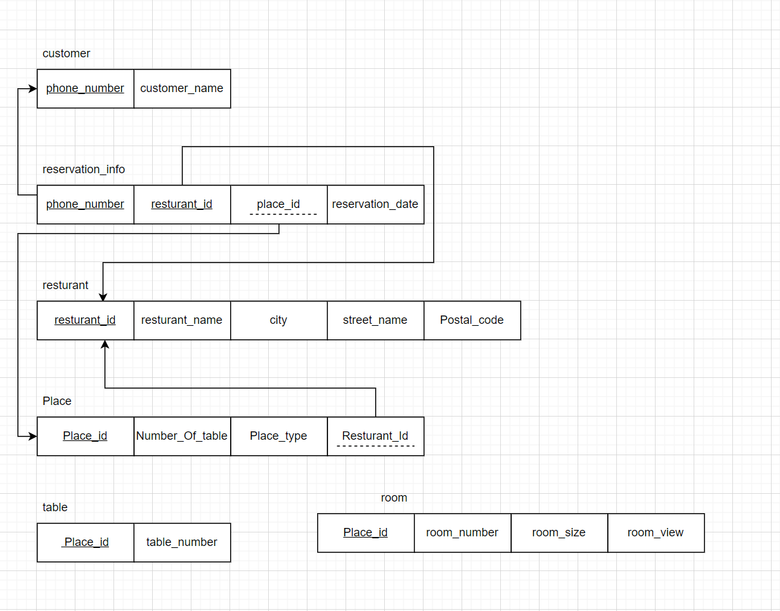

-This relation is already in 3NF because it already fulfilled all the conditions from 1-3NF.

1- there are no repeating groups.

2- a unique key has been identified for each relation.

3- all attributes are functionally dependent on all or part of the key.

4-all non-key attributes are fully functionally dependent on the

entire key.

5-no transitive dependencies.

create table restaurant (

restaurant_id number not null constraint restaurant_pk primary key,

place_id number not null,

restaurant_name varchar2(40) not null,

address varchar2(20)

);

alter table restaurant add constraint restaurant_restaurant_id_uq unique (restaurant_id);

alter table restaurant add constraint restaurant_place_id_uq unique (place_id);

create table reservation_info (

phone_number number not null ,

restaurant_id varchar2(10) not null,

reservation_date date not null,

place_id number

);

alter table reservation_info

add constraint FK_phone

FOREIGN KEY (phone_number) REFERENCES customer(phone_number);

alter table reservation_info

add constraint FK_restaurant_id

FOREIGN KEY (RESTAURANT_PK) REFERENCES restaurant(RESTAURANT_PK);

create table Place (

place_id number not null constraint place_pk primary key,

number_of_tables number not null

);

alter table Place add constraint place_place_id_uq unique (place_id);

create table customer (

phone_number number not null constraint customer_pk primary key,

customer_name varchar2(20) not null

);

create table room (

room_number number not null,

room_size number not null,

room_view varchar2(15) not null,

place_id number not null,

constraint fk_placeid FOREIGN KEY (place_id) REFERENCES place(place_id)

);

create table table_t (

table_number number not null,

place_id number not null,

constraint t_placeid FOREIGN KEY (place_id) REFERENCES place(place_id)

);

insert into restaurant

values (25136,11356,'Shawerma Resturant','Jeddah,alsalamah,47733')

insert into restaurant

values (11562,84532,'Burger Resturant','Jeddah,al rawdah,125400')

insert into restaurant

values (76246,11424,'Kabsah Resturant','Jeddah,Alnaeem,240955')

insert into restaurant

values (15326,32136,'Pizza Resturant','Jeddah,Asfan,213465')

insert into restaurant

values (29424,32168,'Seafood Resturant','Jeddah,Almuhammdyiah,215799')

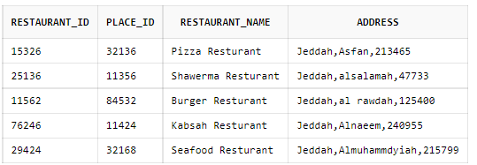

insert into place

values(11356,10)

insert into place

values(84532,7)

insert into place

values(32168,9)

insert into place

values(11424,8)

insert into place

values(32136,11)

insert into room

values (1,'7x7','Garden view',11356)

insert into room

values (2,'8x8','Fountain view',11356)

insert into room

values (1,'5x5','Kitchen view',84532)

insert into room

values (2,'5x5','Standard view',84532)

insert into room

values (1,'6x6','Street view',11424)

insert into room

values (2,'6x6','Street view',11424)

insert into room

values (1,'7x7','Kitchen view',32136)

insert into room

values (2,'4x4','Fountain view',32136)

insert into room

values (1,'7x7','Aquarium view',32168)

insert into room

values (2,'9x9','Beach view',32168)

insert into table_t

values (1,11356);

insert into table_t

values (2,11356);

insert into table_t

values (3,11356);

insert into table_t

values (4,11356);

insert into table_t

values (5,11356);

insert into table_t

values (6,11356);

insert into table_t

values (7,11356);

insert into table_t

values (8,11356);

insert into table_t

values (9,11356);

insert into table_t

values (10,11356)

insert into table_t

values (1,84532);

insert into table_t

values (2,84532);

insert into table_t

values (3,84532);

insert into table_t

values (4,84532);

insert into table_t

values (5,84532);

insert into table_t

values (6,84532);

insert into table_t

values (7,84532);

insert into table_t

values (1,32168);

insert into table_t

values (2,32168);

insert into table_t

values (3,32168);

insert into table_t

values (4,32168);

insert into table_t

values (5,32168);

insert into table_t

values (6,32168);

insert into table_t

values (7,32168);

insert into table_t

values (8,32168);

insert into table_t

values (9,32168);

insert into table_t

values (1,11424);

insert into table_t

values (2,11424);

insert into table_t

values (3,11424);

insert into table_t

values (4,11424);

insert into table_t

values (5,11424);

insert into table_t

values (6,11424);

insert into table_t

values (7,11424);

insert into table_t

values (8,11424);

insert into table_t

values (1,32136);

insert into table_t

values (2,32136);

insert into table_t

values (3,32136);

insert into table_t

values (4,32136);

insert into table_t

values (5,32136);

insert into table_t

values (6,32136);

insert into table_t

values (7,32136);

insert into table_t

values (8,32136);

insert into table_t

values (9,32136);

insert into table_t

values (10,32136);

insert into table_t

values (11,32136);

insert into CUSTOMER

values(0594678400,'Abdullah')

insert into CUSTOMER

values(0547583499,'Ahmed')

insert into CUSTOMER

values(0573261122,'Samer')

insert into CUSTOMER

values(0565447721,'Mohammed')

insert into CUSTOMER

values(0595126666,'Ali')

insert into CUSTOMER

values(0552466771,'Abdulrahman')

insert into reservation_info

values(594678400,25136,'2022-11-12',11356)

insert into reservation_info

values(547583499,11562,'2022-11-16',84532)

insert into reservation_info

values(573261122,76246,'2022-11-18',11424)

insert into reservation_info

values(595126666,15326,'2022-11-18',32136)

insert into reservation_info

values(565447721,29424,'2022-11-18',32168)

//query 4

select *

from customer

join reservation_info

on customer.PHONE_NUMBER = reservation_info.PHONE_NUMBER

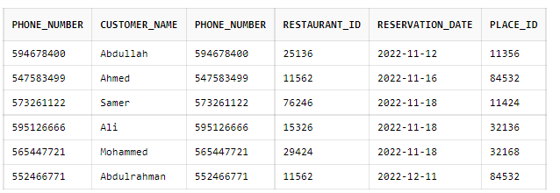

//query1

select customer.customer_name , reservation_info.PHONE_NUMBER,reservation_info.RESTAURANT_ID,reservation_info.RESERVATION_DATE

from customer , reservation_info

where reservation_info.RESERVATION_DATE='2022-11-18'

And reservation_info.phone_number= customer.phone_number;

//query 2

select count (table_number) , place_id

from table_t

group by place_ID

//query 3

select customer_name , phone_number

from customer

where phone_number in

(select phone_number from reservation_info where reservation_date='2022-11-18');

